REPORT

**AUTOMATIC VACUUM CLEANER**

**TEAM MEMBERS**

ARYAN PANDEY – 20BLC1087

ANANYA B – 20BLC1016

SAKSHI AGNIHOTRI – 20BEC1330

**PROBLEMS WE FACED AND SOLUTIONS ARE GIVEN AT THE END OF THE REPORT**

**ABSTRACT**

In the current hectic schedule, cleaning houses and surrounding environment is more hectic. At present, there are vacuum cleaners which require humans to handle it. Thus, there is a dire need to implement vacuum cleaner which works without human intervention. An efficient method to clean the desired area has been implemented through this project. By using this vacuum cleaner, hazardous places can be cleaned which thereby reduce risks to mankind. This is achieved by implementing an autonomous system. Here, obstacle avoiding robot car which is embedded with a vacuum cleaner is used. This system has an ultrasonic sensor attached to it, that helps in avoiding large obstacles such as tables, chairs, walls etc. By measuring the distance via this sensor, the car takes the direction where the distance between obstacle and car is more, hence avoiding the collision with the obstacles.

**INTRODUCTION**

Automated vacuum cleaner is a robotic system that allows for automatic cleaning of a particular area or room by covering the area using border analysis. The robotic system follows a zigzag path to cover entire room. The system uses ultrasonic sensors for boundary sensing and operates accordingly in order to cover entire room. The system also has a vacuum suction cleaner attached to its back for dust suction.

The robot now operates in a zig zag manner by turning once a it faces an obstacle. It covers the complete area automatically.

**BENEFITS OF OUR PROJECT FOR THE SOCIETY**

* In the current COVID situation since social distancing has to be maintained, a greater number of people cannot clean together.
* Since majority belong to the working population, there is always a shortage of time.
* Vacuum cleaner can be used for domestic purposes such as to clean the floor, car, carpets etc. It can be used efficiently in colleges as the space is also large.
* In this era where digital technology is rising rapidly, mankind is becoming more and more dependent on the same.
* Swachh Bharat Mission is an initiative taken by Government of India in the year 2014 to keep the surroundings clean. The main aim of this mission was to make every individual prioritize cleaning as it has huge impact on every living organism's health.

**BLOCK DIAGRAM**

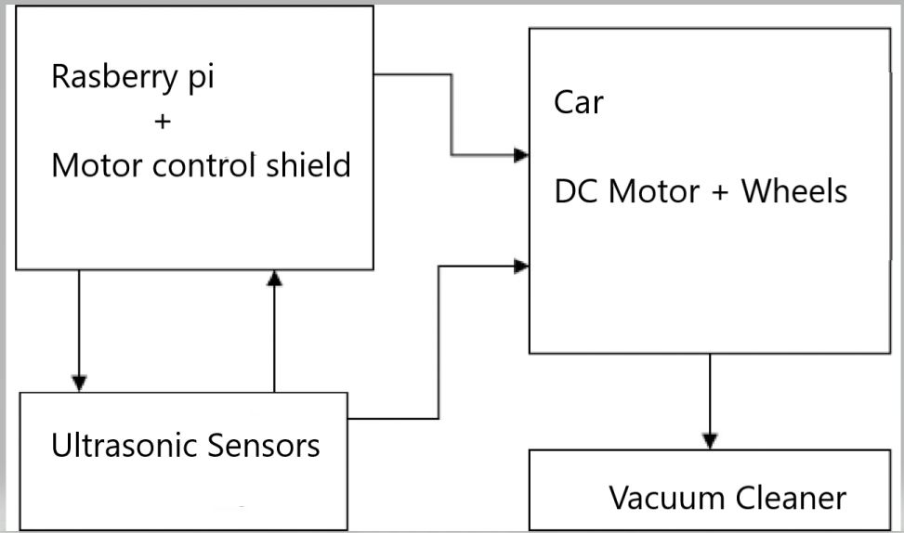

**FLOWCHART**

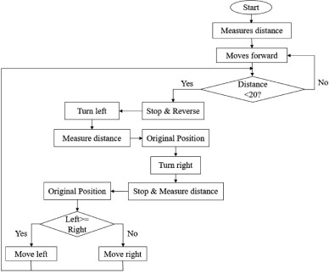

**COMPONENTS**

* Raspberry Pi Pico
* 60 rpm motors -4
* Wheels
* BreadBoard – mini
* UltraSonic Sensor -HC058
* Robot Chasis
* L298N motor driver
* Sensor holder
* SG90 micro servo
* Batteries
* Battery holder
* Jumper wires

**CIRCUIT DIAGRAM**

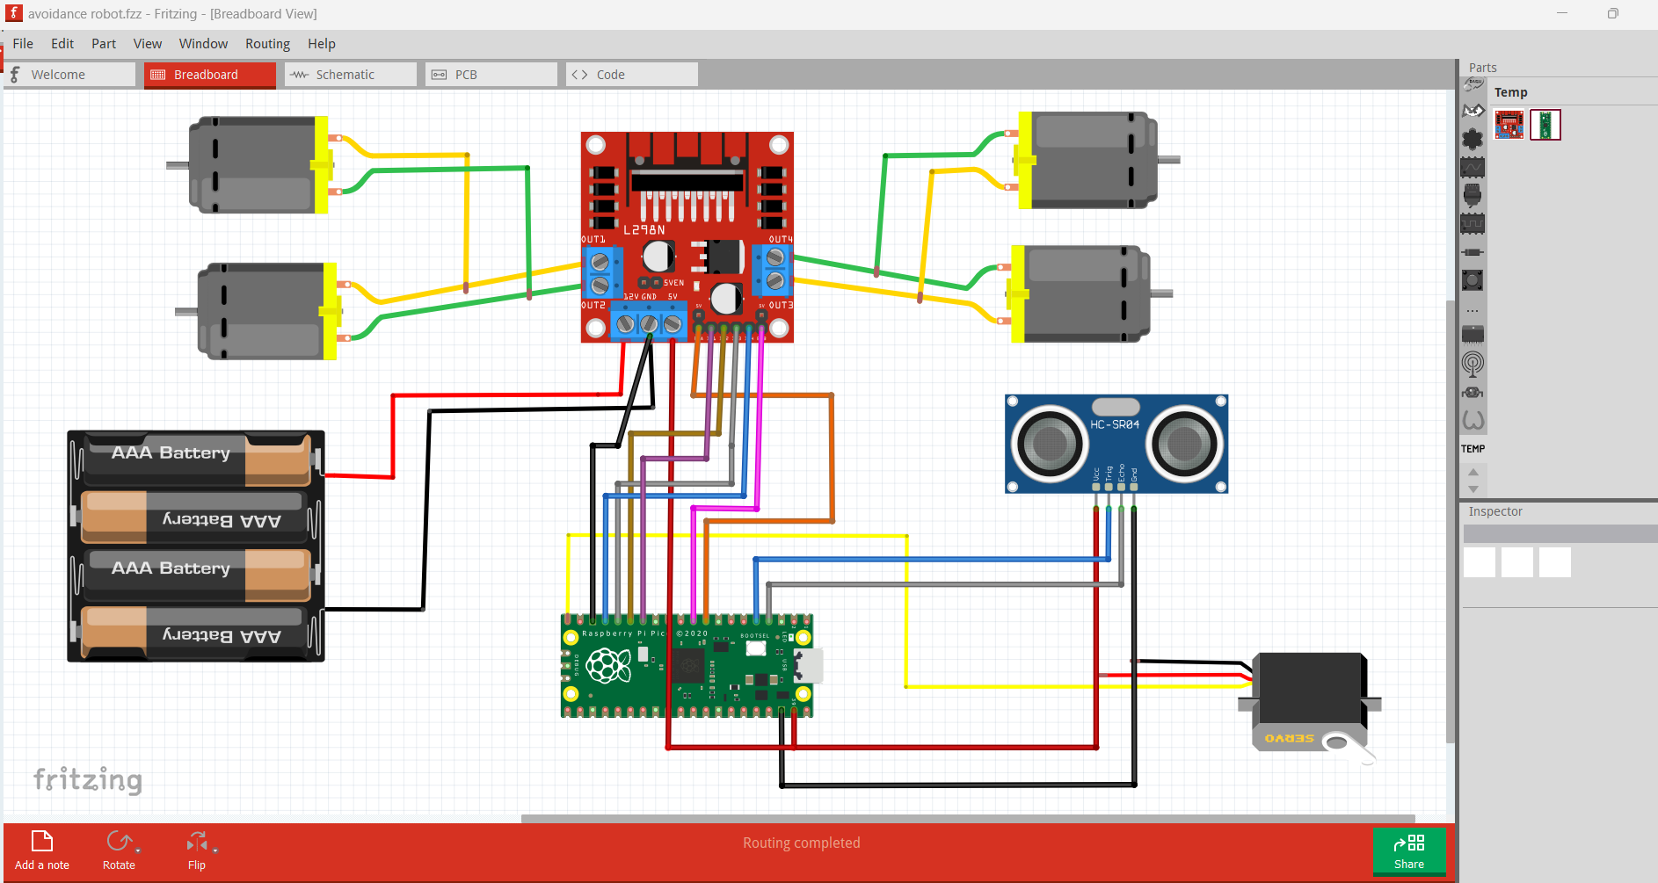

**SOFTWARE SIMULATIONS ON FRITZING: -**

**PCB DESIGN:**

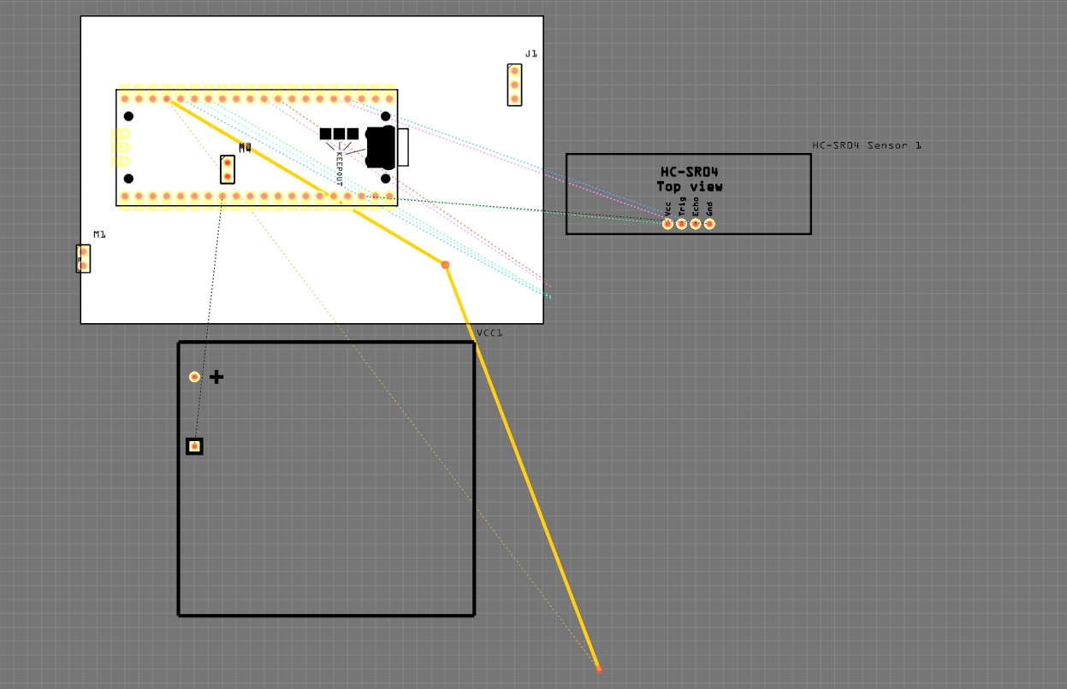

**OUTPUT: -**

**ALL WORKING CONNECTIONS WITH ZERO ERRORS: -**

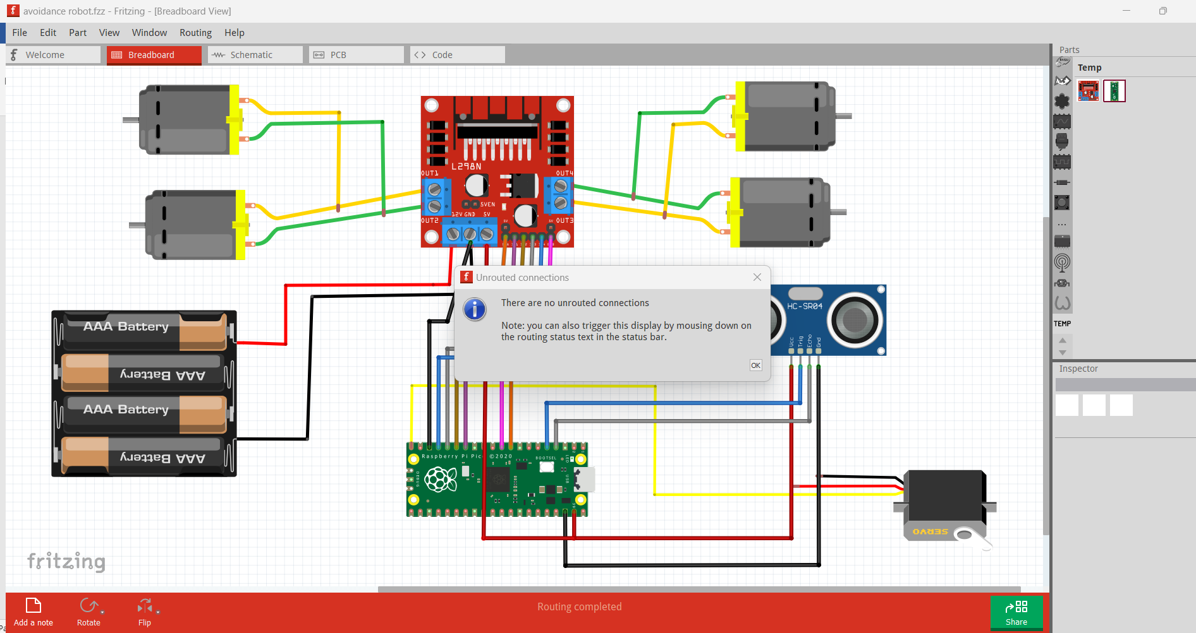

**CODE:**

from machine import Pin,PWM #importing PIN and PWM  
import time #importing time  
import utime  
  
# Defining motor pins  
motor1=Pin(10,Pin.OUT)  
motor2=Pin(11,Pin.OUT)  
motor3=Pin(12,Pin.OUT)  
motor4=Pin(13,Pin.OUT)  
# Defining enable pins and PWM object  
enable1=PWM(Pin(6))  
enable2=PWM(Pin(7))  
  
# Defining Trigger and Echo pins  
trigger = Pin(3, Pin.OUT)  
echo = Pin(2, Pin.IN)  
  
# Defining Servo pin and PWM object  
servoPin = Pin(15)  
servo = PWM(servoPin)  
duty_cycle = 0 # Defining and initializing duty cycle PWM  
  
# Defining frequency for servo and enable pins  
servo.freq(50)  
enable1.freq(1000)  
enable2.freq(1000)  
  
# Setting maximum duty cycle for maximum speed  
enable1.duty_u16(65025)  
enable2.duty_u16(65025)  
  
# Forward  
def move_forward():  
 motor1.low()  
 motor2.high()  
 motor3.high()  
 motor4.low()  
   
# Backward  
def move_backward():  
 motor1.high()  
 motor2.low()  
 motor3.low()  
 motor4.high()  
   
#Turn Right  
def turn_right():  
 motor1.low()  
 motor2.high()  
 motor3.low()  
 motor4.high()  
   
#Turn Left  
def turn_left():  
 motor1.high()  
 motor2.low()  
 motor3.high()  
 motor4.low()  
   
#Stop  
def stop():  
 motor1.low()  
 motor2.low()  
 motor3.low()  
 motor4.low()  
   
# Defining function to get distance from ultrasonic sensor  
def get_distance():  
 trigger.low()  
 utime.sleep_us(2)  
 trigger.high()  
 utime.sleep_us(5)  
 trigger.low()  
 while echo.value() == 0:  
 signaloff = utime.ticks_us()  
 while echo.value() == 1:  
 signalon = utime.ticks_us()  
 timepassed = signalon - signaloff  
 dist = (timepassed * 0.0343) / 2  
 return dist  
  
#Defining function to set servo angle  
def setservo(angle):  
 duty_cycle = int(angle*(7803-1950)/180) + 1950  
 servo.duty_u16(duty_cycle)  
  
setservo(90)  
  
while True:  
 distance=get_distance() #Getting distance in cm  
   
 #Defining direction based on conditions  
 if distance < 15:  
 stop()  
 move_backward()  
 time.sleep(1)  
 stop()  
 time.sleep(0.5)  
 setservo(30) #Servo angle to 30 degree  
 time.sleep(1)  
 right_distance=get_distance()  
 #print(right_distance)  
 time.sleep(0.5)  
 setservo(150) #Servo angle to 150 degree  
 time.sleep(1)  
 left_distance=get_distance()  
 #print(left_distance)  
 time.sleep(0.5)  
 setservo(90)  
   
 if right_distance > left_distance:  
 turn_right()  
 time.sleep(2)  
 stop()  
 else:  
 turn_left()  
 time.sleep(2)  
 stop()  
 else:  
 move_forward()  
  
 time.sleep(0.5)

**ON BOARD CONNECTION1S:**

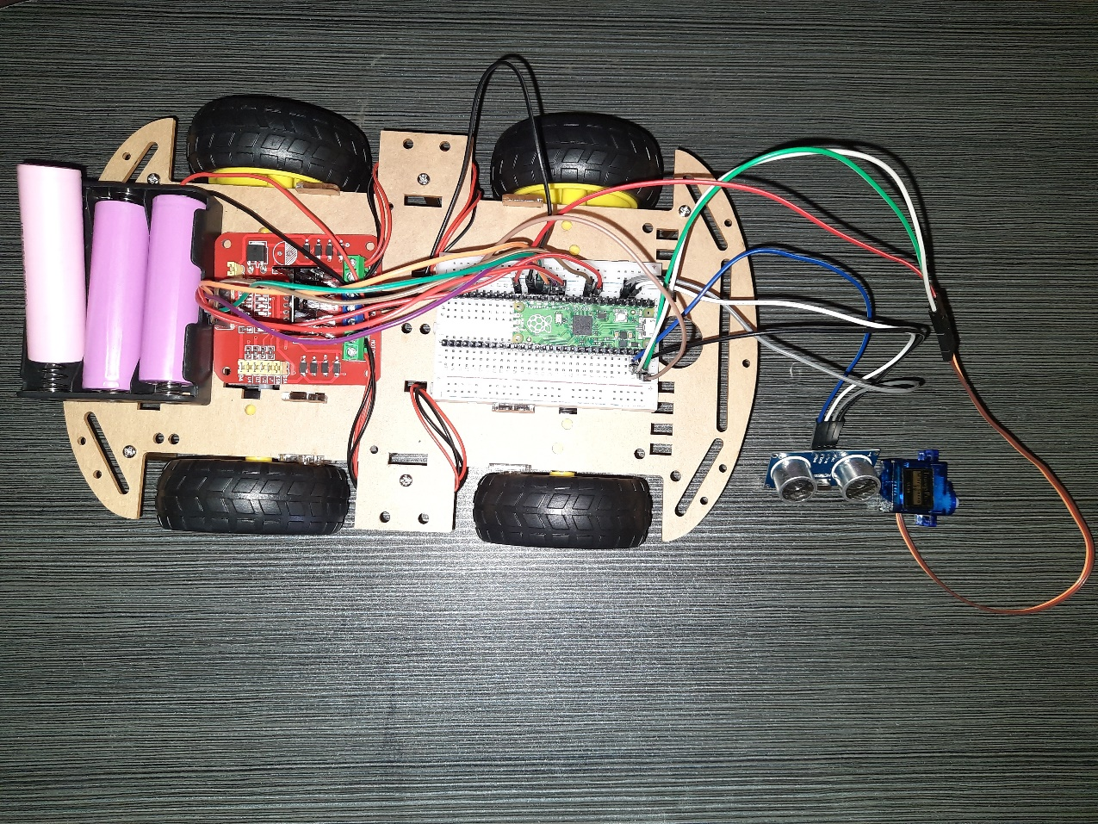

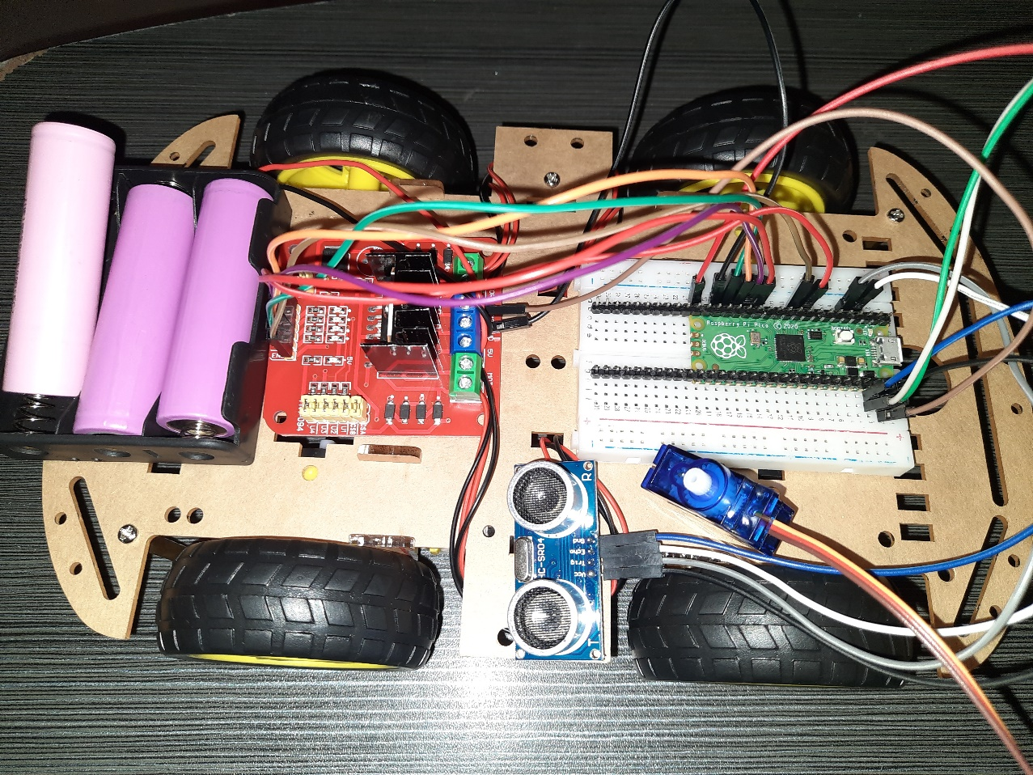

**COSTING: -**

L298N Dual H Bridge DC Stepper Motor Driver Controller Module ₹279

18650 Lithium Battery Holder for Battery 3 x 18650 Cell ₹54

Raspberry Pi Pico New model Original ₹339

Li-Ion 18650 3.7V 2200MAH Battery-1C - XTT ₹109

Mounted Holder for HC-SR04 Ultrasonic Sensor Module ₹49

DC 12V 500RPM Metal Geared Motor ₹596

White for 4 Wheel ( 4WD ) 4 motors Robotics DIY Kit - 250x135x60 mm ₹189

20cm Male To Female Jumper Cable Wire For Arduino - 10pcs ₹19

TOWER PRO SG90 9G MICRO SERVO MOTOR ₹134

Smart Robot Car Wheels For Arduino BO Gear Motor Chassis ₹156

Ultrasonic Module HC-SR04 Distance Measuring Sensor ₹74

Mini Solderless Breadboard -170 Tie Points for Arduino, DIY Project ₹49

Sub-Total ₹2,047

Express Shipping ₹49

**Total ₹2,096**

**CONCLUSION:**

Today we are in the world of robotics. Knowingly or unknowingly, we have been using different types of robots in our daily life. The aim of the thesis is to evaluate what can learn about the fields of engineering, mechatronics, and software development as they design, construct, and program an autonomous robot. This will to provide a guideline to who are new in the world of Raspberry pi -pico and help them to understand about embedded system, IR sensors, microcontroller and how to make a robot using Raspberry pi. This project had the goal of manipulating different parts of the robot to make it react according to our desire. The overall end objective was to make the robot avoid obstacle just by programming it to use the sensors attached to it.

**PROBLEMS WE FACED: -**

While building the robot the connections were all right but the L298N Motor Driver IC was not able to handle the power supply – 12Volt given by us. We changed our Motor driver once as the first one got burned but the second one also got heated up. Individually all the components are working and we checked the connections of wires through the fritzing software which indicated that nothing is “unrouted” in our software connections

The possible solutions which we came up with our to

* Use a L298N Motor Driver Shield
* Use a constant power supplier
* Use a power bank to supply the constant voltage so that the motor works

**REFERENCES:**

* [**https://www.youtube.com/watch?v=w0E2aDWQj-M**](https://www.youtube.com/watch?v=w0E2aDWQj-M)
* [**https://www.theseus.fi/bitstream/handle/10024/71120/lok_final_thesis.pdf?sequence=1&isAllowed=y**](https://www.theseus.fi/bitstream/handle/10024/71120/lok_final_thesis.pdf?sequence=1&isAllowed=y)
* [**https://www.slideshare.net/shubhamthakur614/final-report-obstacle-avoiding-roboat**](https://www.slideshare.net/shubhamthakur614/final-report-obstacle-avoiding-roboat)
* [**https://www.youtube.com/watch?v=oyVITlwb8Lk&t=39s**](https://www.youtube.com/watch?v=oyVITlwb8Lk&t=39s)
* [**https://www.youtube.com/watch?v=X_xYzqkrhTc**](https://www.youtube.com/watch?v=X_xYzqkrhTc)
* [**https://www.youtube.com/watch?v=aE_J7B-O4VQ**](https://www.youtube.com/watch?v=aE_J7B-O4VQ)